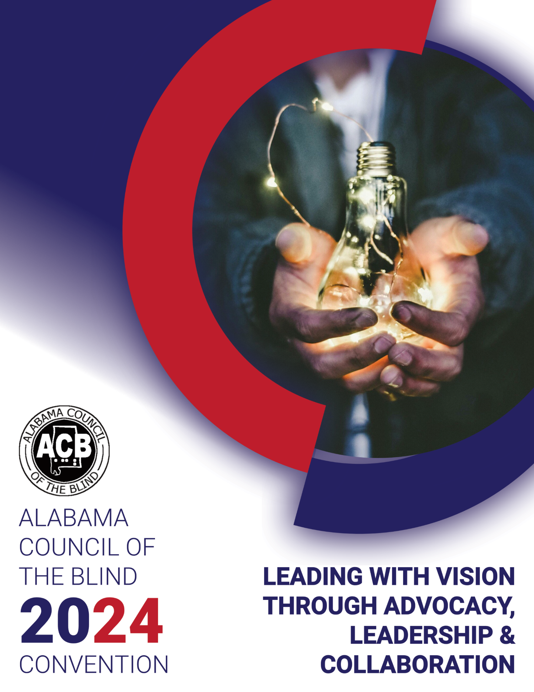

Contents

Alabama Council of the Blind 2024 State Conference and Convention 4

Alabama Council of the Blind 2023-2024 6

Executive Board of Directors 6

Board Members 6

Board of Publications 6

“A Special Thank You” 7

Alabama Council of the Blind Conference Planning Committee 7

Thank you to our Volunteers, Presenters and Exhibitors! 7

A HUGE thanks to Alabama Department of Rehabilitation Services and Alabama Institute for the Deaf and Blind for their continued support to ALCB! 7

**“Leading with Vision: Through Advocacy, Leadership and Collaboration”** 8

Program Agenda 8

Friday, August 16th 8

7:00 PM – 9:00 PM: General Session 9

Saturday, August 17th 10

8:45 AM – 12:00 PM: General Session 10

Sunday, August 18th 12

Presenter Profiles 13

Scott Thornhill Executive Director – American Council of the Blind, Alexandria, Virginia 13

Lorenzo Brown Executive Director – The Is-Able Center, Homewood, Alabama 15

Cheryl McNeil Fisher – Author, Motivational Speaker & Creator & Co-Host of Award-Winning Podcast 18

Scott Falcone – Director Statewide Outreach Services, South Carolina School for the Deaf and the Blind 20

Cary Baxter, MD – Ophthalmologist/ Retina Specialist 21

Jack S. Parker, MD – Cornea Specialist/Surgeon 22

Dennis Gilliam, Ed.D., – President of AIDB 23

Jane Elizabeth Burdeshaw – Commissioner, Alabama Department of Rehabilitation Services 24

Ashley Townsend – Assistant Commissioner and Director of Special Programs, Alabama Department of Rehabilitation Services 25

Senator Lance Bell – Alabama Senate, District 11 26

Conference Exhibits 27

Accessing Potential Through Assistive Technology (APTAT) (Formerly STAR program) 27

ADRS VRT & O&M Information 27

AIDB AIRA-Gentry 27

AIDB – Assistive Technology (AT) 28

AIDB Birmingham Regional Center 28

AIDB Center for Assistive Technology Training (CATT) 28

AIDB Huntsville Consumer Store 28

Alabama Association for the Education and Rehabilitation for the Blind and Visually Impaired, (AERBVI) 29

Alabama Business Enterprise Program (BEP) 29

Alabama Council of the Blind – Huntsville Chapter 29

Alabama Industries for the Blind 30

Alabama Library for the Blind and Physically Disabled 30

A T Guys 30

Blind Girl Designs 30

Blind Limitless Clothing LLC 31

Emerald Coast Vision Aids 31

Lakeshore Foundation 31

OrCam Inc. 31

Tactile Engineering 32

UAB Department of Occupational Therapy 32

United Way Area Agency On Aging (UWAAA) 32

Veterans Affairs Blind Rehabilitation Services Birmingham VA Health Care System 32

# Alabama Council of the Blind 2024 State Conference and Convention

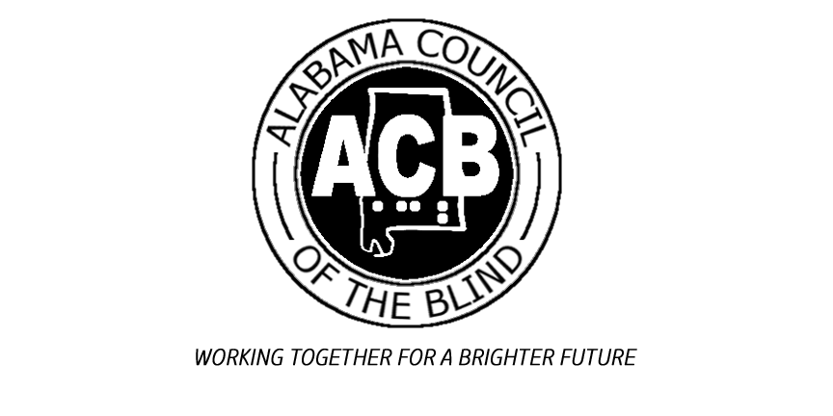

**Dear ALCB Members, Friends, and Partners,**

**On behalf of The Alabama Council of the Blind, it is my distinct pleasure to welcome you to the 2024 Conference and Convention! We are thrilled to have you join us for this exciting event, where we will gather to share knowledge, foster connections, and celebrate our achievements.**

**This year’s convention promises to be one of our most engaging and dynamic yet, with a diverse lineup of speakers and networking opportunities designed to inspire and empower each of you. Our theme, “Leading with Vision: Through Advocacy, Leadership and Collaboration” reflects our commitment to create a world without barriers for the blind and visually impaired community, and we are excited to work together with you on this important mission over the next few days.**

**I would like to extend my deepest gratitude to our dedicated planning committee, volunteers, sponsors, and partners, whose hard work and support have been instrumental in bringing this convention to life. Their contributions ensure that we can provide a high-quality experience for all attendees.**

**Throughout the convention, I encourage you to take full advantage of the opportunities available to you. Engage with our esteemed speakers, participate in the interactive sessions, and connect with your fellow attendees. These interactions are the heart of our convention, and they foster the collaboration and innovation that drive our organization forward.**

**We are also proud to showcase the accomplishments of our members and highlight the advancements within our field. I hope you leave this convention feeling inspired, informed, and motivated to apply what you’ve learned in your respective roles.**

**Thank you for being a part of the Alabama Council of the Blind community and for joining us at this year’s conference and convention. Your presence and participation are what make this event truly special.**

**Enjoy the convention!**

**Warm regards,**

**Michael Talley, President**



# Alabama Council of the Blind 2023-2024

## Executive Board of Directors

**President – Michael Talley**

**1st Vice President – Rod Skene**

**2nd Vice President – Nancy Pendegraph**

**Treasurer – Donovan Beitel**

**Secretary – Penny Moss**

## Board Members

**Birmingham – Ken Osbourn**

**Huntsville – Debbie Drylie**

**Talladega – Rhonda Trott**

**Virtual – Bill Adams**

## Board of Publications

**David Trott, Chair**

**Kim Carmichael**

**Debbie Culver**

**Jimmie Smith**

**Angela Talley**

# “A Special Thank You”

## Alabama Council of the Blind Conference Planning Committee

**Convention Chair – Joan Garrett**

**Debbie Culver**

**Penny Moss**

**Jennifer Reeves**

**Valerie Sherbert**

**Courtney Smith**

**Michael Talley**

**Program Book – Angela Talley, Jonathan and Valerie Sherbert, Jane Ogal and Teresa Lacy**

**Registration – Donovan Beitel and Bill Adams**

**ALCB Website – Bill Adams**

## Thank you to our Volunteers, Presenters and Exhibitors!

## A HUGE thanks to Alabama Department of Rehabilitation Services and Alabama Institute for the Deaf and Blind for their continued support to ALCB!



***“Working Together for A Brighter Future”***

Alabama Council of the Blind



2024 State Conference and Convention

August 16th – 18th, 2024

Embassy Suites by Hilton Birmingham/Hoover

2960 John Hopkins Parkway

Birmingham, Al 35244

**“Leading with Vision: Through Advocacy, Leadership and Collaboration”**

# Program Agenda

## Friday, August 16th

**8:00 AM – 9:00 AM: Pre-Registration Pick Up**

**9:00 AM – 11:00 AM: Preconference - Leadership Presentation by Scott Thornhill Executive Director, American Council of the Blind**

**10:00 AM – 5:00 PM: Exhibits Open**

**11:00 AM – 1:00 PM: Lunch on your own**

**1:00 PM – 5:00 PM: Onsite Registration and Pre-Registration Pick Up**

**1:30 PM – 2:00 PM: Scott Falcone, Director Statewide Outreach Services, Columbia, South Carolina School for the Deaf and the Blind**

**2:00 PM – 3:30 PM:**

* **Sereniti Sanders, ASB student performance**
* **Legislative forum, Senator Lance Bell**
* **AIDB Update, Dr. Dennis Gilliam, AIDB President**
* **ADRS Update, Jane Elizabeth Burdeshaw, ADRS Commissioner**
* **Ability One Panel – Scott Thornhill and Jeff Papalia**

**3:30 PM – 4:00 PM: Nominating, Credentials, and Auditing/Budget Committee Meetings**

**4:00 PM – 5:00 PM: State ACB Board Meeting**

**5:00 PM – 7:00 PM: Dinner on your own**

### 7:00 PM – 9:00 PM: General Session

**7:00 PM – 7:15 PM:**

* **Welcome – Michael Talley, ALCB President**
* **Remarks – Joan Garrett, Conference and Convention Chairperson**
* **Invocation – Ken Osbourne**
* **National Anthem and Presentation of Colors**
* **Sereniti Sanders, ASB student performance**

**7:15 PM – 8:00 PM: Keynote Speaker – Lorenzo Brown, Executive Director, The Is-Able Center**

**8:00 PM – 8:45 PM: Cheryl McNeil Fisher, Blind Author**

**8:45 PM – 9:00 PM:**

* **American Council of the Blind National update,   
  Scott Thornhill**
* **Roll Call of Delegates, Penny Moss, State Secretary**

**9:00 PM – 9:30 PM: Exhibitor Reception with Ice Cream Bar**

**9:30 PM – 11:00 PM: Bingo**

## Saturday, August 17th

**8:00 AM – 9:00 AM: Registration - Onsite and Pre-Registration Pick Up**

**8:00 AM – 12:00 PM: Exhibits Open**

### 8:45 AM – 12:00 PM: General Session

**8:45 AM – 9:00 AM: Opening Remarks & Announcements**

* **Michael Talley, ALCB President**
* **Joan Garrett, Conference and Convention Chairperson**

**9:00 AM – 10:00 AM: Speakers - Ophthalmologist**

* **Dr. Jack Parker, Corneal Research and Techniques**
* **Dr. Cary Baxter, Retina Research and Innovation**

**10:00 AM – 10:15 AM: ADRS update, Ashley Townsend, MA,**

**CRC, Assistant Commissioner, Deaf and Blind Services, Vocational Rehabilitation Services**

**10:30 AM – 11:45 AM: AIDB & ADRS Direct service panel**

**Moderator Jennifer Reeves M.Ed., CRC, Case Manager for the Blind, E.H. Gentry**

* **Russell Craig, Outreach Vocational Evaluator Services for the Blind E. H. Gentry Facility**
* **Courtney Pettway, MS, CRC Case Manager for the Blind Montgomery Regional Center**
* **Marquita Mansfield, Ed.S., LPC Senior Vocational Rehabilitation Counselor for the Blind at Alabama Department of Rehabilitation Services**
* **AFCB Representative, TBD**

**11:45 AM – 12:00 PM: Audience Q&A**

**12:30 PM – 1:30 PM: Awards/Scholarship Luncheon**

* **Awards Presentation: Michael Talley, State ACB President**
* **Remarks: 2024 Byrd Bryant Scholarship Award Recipient**
* **AIDB & ADRS Successful Outcome Panel**

**2:30 PM – 4:00 PM: ALCB Business Meeting**

**7:00 PM – 10:00 PM: Mixer – Heavy hors d’oeuvres and Karaoke**

## Sunday, August 18th

**9:00 AM – 10:00 AM:**

* **Devotion**
* **Installation of Officers**
* **Concluding Remarks – Michael Talley, ALCB President**

**  
The Alabama Department of Rehabilitation Services is co-sponsoring this event and pending approval from the Commission on Rehabilitation Counselor Certification (CRCC) to sponsor continuing education credits for counselors.**

# Presenter Profiles

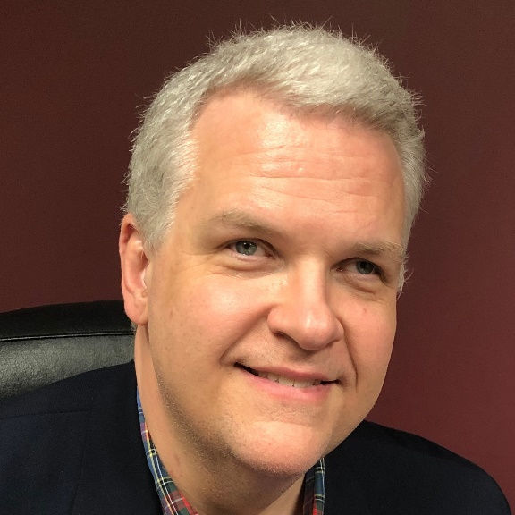

## Scott Thornhill Executive Director – American Council of the Blind, Alexandria, Virginia

**Scott Thornhill took office as the new**

**Executive Director of the American**

**Council of the Blind (ACB) on March 18,**

**2024. Thornhill was voted in by the ACB Board to lead the 62-**

**year-old organization.**

**Thornhill holds a Master of Public Administration**

**from the University of North Carolina-Wilmington, as well as a**

**post baccalaureate Certificate in Non-Profit Management from**

**the University of North Carolina-Greensboro.**

**"It is an honor and a privilege to be able to lead an organization**

**with such a rich history," said Thornhill. "The strength of ACB**

**is a combination of our members, our supporters, and the larger**

**blindness community that we serve. I look forward to us**

**achieving even more impactful results in the years to come."**

**For the past five years, Thornhill served as the Director of Public**

**Policy for Alphapointe, a non-profit organization with the**

**mission to empower people who are blind through**

**opportunities for employment and personal development. In**

**that role, he was responsible for issues such as government**

**relations, successful employment, innovation, event**

**fundraising in New York and more.**

**Thornhill also has a background in real estate brokerage.**

**Despite a flourishing career in that field, he felt compelled to**

**join the effort to help make the playing field level for people who**

**are blind and visually impaired. Thornhill is blind himself, losing**

**his vision due to retinitis pigmentosa (RP) after being**

**diagnosed at the age of eight and told at 15 he would be blind**

**by 40.**

**Thornhill brings experience from the non-profit world as well as**

**corporate management to his new position. In addition to his**

**business ownership and employment, Thornhill has served on**

**multiple non-profit boards, including Industries of the Blind in**

**Greensboro, NC. He has been active with the National**

**Association for the Employment of People who are Blind, as**

**well as VisionServe Alliance.**

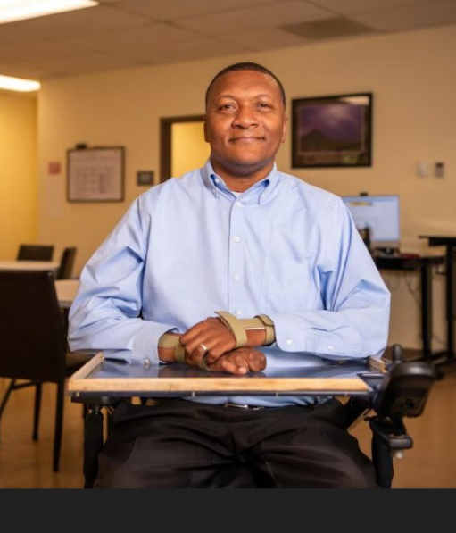

Lorenzo Brown Executive Director   
– The Is-Able Center, Homewood, Alabama

**Lorenzo Brown was shot in the neck, at the age of 17, and paralyzed from his chest down. The first time he opened his eyes after being gunned down, he woke to find that he was permanently paralyzed, on life support, and his chances of making it out of the hospital alive were slim.**

**Now age 47, Brown is executive director of the Is-Able Center,**

**which he opened in 2017 and operates with five payroll**

**employees and three volunteers, who serve as employment**

**specialists, including his wife of 17 years, Amy Brown.**

**All services provided by The IS-Able Center are free.**

**The center is dedicated to empowering, educating and**

**encouraging people in the disability community. “We took the**

**d’s out of disabled, and we are The Is-Able Center. Our**

**mission is to enhance the quality of life of individuals with**

**disabilities, their loved ones, and their caregivers. Our aim is**

**to equip them with tools, resources, and information so that**

**they can live more independent lives.**

**The IS-Able Center, located in Homewood at 244 West Valley**

**Ave., Suite 206, operates five days a week and provides job**

**readiness, computer and self-advocacy training, life skills, and**

**depression and grief support groups. The center also does**

**outreach programming in Birmingham-area high schools.**

**The IS-Able Center also has job placement partnerships with the University of Alabama at Birmingham (UAB) Hospital Services and Sodexo, a food and facilities management company, with which Brown has had contracts with for years.**

**The Is-Able Center has come a long way. Nearly 20 years after**

**the ADR moved Brown to Birmingham and helped him get his**

**own apartment and a vehicle, he could operate himself, the IS**

**Able nonprofit formed a partnership with Alabama Department**

**of Rehabilitation (ADR) in 2017. “It came full circle, I went from**

**being a client to being one of their service providers.” said**

**Brown.**

**Future plans for the IS-Able organization include opening a**

**transitional living facility similar to the one that changed**

**Brown’s life. “That facility was a game-changer in my life,” he**

**said. “With a transitional living facility, we would bring in**

**people who are injured, train them, and give them the same**

**services offered at our center.” “People in other states or rural**

**communities would live at the facility for 30 to 90 days, and**

**we’d provide them with those services, as well as physical**

**therapy and occupational therapy to equip them to live an**

**independent life,” said Brown, adding that strategic plans are**

**underway to open the transitional living facility, which he**

**hopes to open in two years.**

**The Marion, Alabama, native never attended high school but**

**earned a General Education Development (GED) diploma in**

**1998 and then went on to attend UAB, where he studied**

**business finance for two years before leaving in 2000 to**

**pursue his call in the ministry. In 2002, he began apprenticing**

**under Bishop Steve Franklin of Covenant Heirs International**

**Church in Birmingham and was ordained as a minister in 2004.**

**On the spiritual side, Brown has authored several books,**

**including “31 Principles for Daily Living: 31-Day Devotional**

**and Journal” and “Moments of Inspiration: 52-Week**

**Devotional and Journal.” He also speaks and works with**

**various organizations, programs, and services to serve people**

**with disabilities. Brown especially has a heart for those**

**suffering from depression and grief and would often host**

**support group meetings because of what he had been**

**through.**

**Brown, a father of four—daughter, Marilyn, 29, twin**

**sons, Isaac and Isaiah, 13; and his youngest son, Jeremiah,**

**6—looks back on his life before he found resources and says**

**the memories have not faded. He considers being shot “a**

**blessing.” “If someone can say that being shot and becoming**

**paralyzed is a blessing, that goes to show you they had a**

**pretty rough life before that,” said Brown. “This led to me**

**having a better life and becoming a better man. When I look in**

**the mirror now, I like the man that I see. This was a blessing in**

**disguise. He added, “If I had to go back and live my journey all**

**over again, even becoming paralyzed, if it’s going to lead to**

**being the man I am today and living the purpose I live now, I’d**

**do it all over again.”**

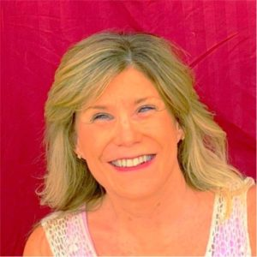

Cheryl McNeil Fisher   
– Author, Motivational Speaker & Creator & Co-Host of Award-Winning Podcast

**Cheryl is the creator and co-host of the**

**Award Winning podcast, Writing Works**

**Wonders, a podcast and website that**

**provides information, resources, and support for writers of all**

**levels and abilities, as well as unforgettable interviews with**

**Beginning authors and #1 NY Times Bestsellers. With over 25**

**years of experience as an author, speaker, life-coach and**

**counselor, Cheryl brings a wealth of knowledge and**

**inspiration to her listeners and clients. She is passionate**

**about helping people discover and express their unique voice**

**and vision through writing and other creative outlets.**

**Cheryl inspires audiences and readers to discover their**

**strengths to face setbacks and reach their dreams.**

**In her career and volunteer work, Cheryl advocates for**

**children and adults with a full spectrum of unique traits. She**

**co-hosts the widely popular podcast Writing Works Wonders**

**with Kathy. She initiated Writing Works Wonders as a Zoom**

**call through the American Council of the Blind. In the spring of**

**2021 she invited Kathy to join her as co-host on Writing Works**

**Wonders. Part of the success of the series is the**

**complementary nature of their personalities and skills, along**

**with the dynamic team they have created. Her publications**

**range from fiction to nonfiction. Her creative children's books**

**nurture imagination, goodness, kindness, and thankfulness**

**while introducing the lifestyles of differently abled people.**

**Audiences benefit from Cheryl's counseling background**

**through her positive, supportive perspective. She uses**

**technology extensively in marketing her book and author**

**brand. Since childhood, Cheryl has experienced low vision but**

**with contact lenses, had 20/30 vision. Then, in her early**

**thirties, she experienced a sudden change that left her legally**

**blind. This began Cheryl's speaking career. "When life turns**

**upside down, we grab on and make it the ride of our life!"**

**After losing most of her eyesight, she learned to adapt to her**

**new reality. She has spoken to various audiences across the**

**country, from schools and organizations to conferences and**

**retreats, on topics such as overcoming challenges, living fully,**

**and using a guide dog. She also offers spiritual counseling**

**and coaching for individuals and groups who seek guidance**

**and empowerment. Cheryl's motto is "Don't give up. We are all**

**differently abled. Let's live in the solution."**

**Cheryl lives in the Hudson Valley with her husband, retired**

**guide dog, Sanka and current guide Raven.**

**Contact:** [**cmcneilfisher@gmail.com**](mailto:cmcneilfisher@gmail.com)

[**www.CherylMcNeilFisher.com**](http://www.CherylMcNeilFisher.com)

[**www.WritingWorksWonders.com**](http://www.WritingWorksWonders.com)

[**Info@WritingWorksWonders.com**](mailto:Info@WritingWorksWonders.com%20)

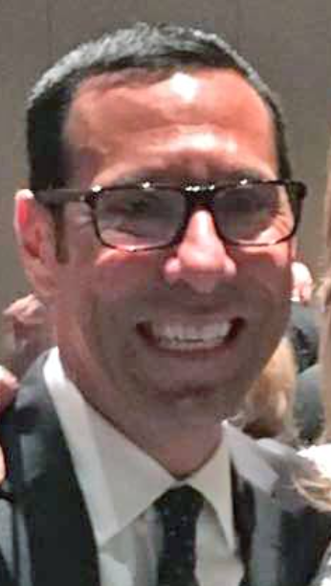

## Scott Falcone – Director Statewide Outreach Services, South Carolina School for the Deaf and the Blind

**Scott Falcone is a Division Director, The of Outreach Services at South Carolina School for the Deaf and the Blind based in Spartanburg, South Carolina. Previously, Scott was a Board Member at the Conference of Educational Administrators of Schools and Programs for the Deaf (CEASD) and held positions at State of South Carolina.**

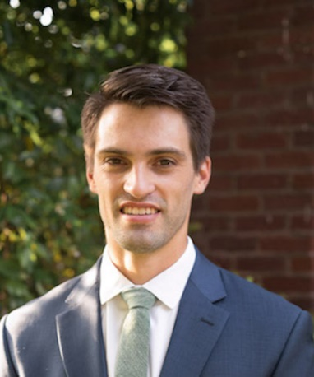

Cary Baxter, MD   
– Ophthalmologist/ Retina Specialist

**Cary Baxter, MD, was born in North Carolina, but spent most of his life in Birmingham, AL. He attended undergraduate school at The University of Alabama and was a member of the baseball team during his time at the university. Dr. Baxter received his medical degree at the University of Alabama at Birmingham (UAB) prior to completing ophthalmology residency at the University of Mississippi Medical Center, where he served as chief resident during the 2022-23 academic year. Dr. Baxter is currently in his final year of surgical retinal fellowship at Retina Specialists of Alabama. His particular areas of interest include prevention and treatment of retinal detachment, and treatment of macular diseases. He currently lives in Birmingham with his wife, Allie, and 9-month-old daughter, Ruth.**

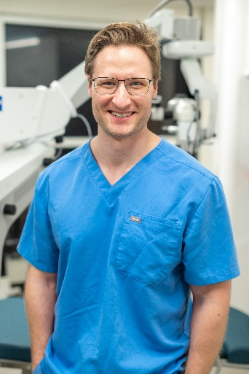

## Jack S. Parker, MD – Cornea Specialist/Surgeon

**Dr. Jack S. Parker is the highest volume corneal transplant surgeon in the world. He is the only American ever trained directly by the inventor of partial corneal transplantation, Dr. Gerrit Melles, who he spent 10 years working with in Rotterdam, Holland. He is the author of hundreds of scientific articles and books dedicated to complicated cornea, and practices locally at Parker Cornea, a high-volume referral-based practice with seven locations (and counting) in Alabama and Mississippi.**

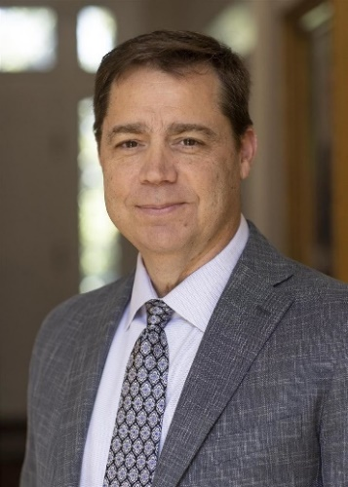

## Dennis Gilliam, Ed.D., – President of AIDB

**Dr. Dennis Gilliam, Ed.D. assumed the role of eighteenth President of AIDB on September 1, 2023. Prior to this position, Dr. Gilliam served as AIDB’s Vice President of Instructional Programs. Dr. Gilliam is a veteran educator with over 30 years of classroom and administrative experience in special education programs and outreach. In addition to his role as Vice President of Instructional Programs, Dr. Gilliam has also served as Executive Director of Special Projects, Special Education Coordinator for AIDB, Middle/High School Academic Director at Alabama School for the Deaf and High School Mathematics Teacher at Alabama School for the Blind.  
“It is my distinct honor to be named the next President of the Alabama Institute for Deaf and Blind. I have spent nearly all of my life in commitment to AIDB and am dedicated to an expectation of excellence, ensuring the level of service we have come to expect from AIDB statewide and throughout the nation,” said Gilliam. “It is a humbling realization that the AIDB Board of Trustees is entrusting me to lead this amazing institution that has provided me, and my family, limitless opportunities to grow, learn and succeed.”  
Dr. Gilliam earned a Doctor of Education, Deaf Studies Deaf Education; Educational Administration Certification; Visual Impairment Education Certification; and a Bachelor of Science and Master of Arts in Secondary Education, Mathematics. Dr. Gilliam also completed the STAR/CAEBER/AEBPD Schools on Bi-Lingual/Bi-Cultural (Deaf) Education program.**

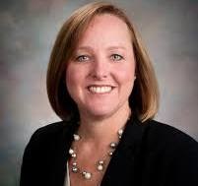

## Jane Elizabeth Burdeshaw – Commissioner, Alabama Department of Rehabilitation Services

**Jane Elizabeth Burdeshaw is the ADRS Commissioner. She began her career with ADRS in 1998 as a rehabilitation counselor for SAIL, and then for Vocational Rehab Service. She served as a Rehab Specialist from 2001 to 2009 coordinating staff training and development. She was promoted in 2009 to serve as the Director of the Human Resources Department until her appointment as Commissioner in 2016.**

**Her academic credentials included an undergraduate degree in psychology and a graduate degree in counseling and human development.**

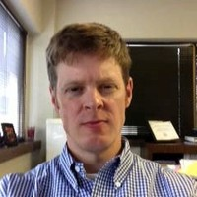

## Ashley Townsend – Assistant Commissioner and Director of Special Programs, Alabama Department of Rehabilitation Services

**Ashley Townsend has worked for ADRS since 2009. He served as a field supervisor from 2009 to 2014. In 2014 he was promoted to Director of Special Programs.  
In 2022 he was named as the Assistant Commissioner of Alabama Department of Rehabilitation Services.**

**His academic credentials include an undergraduate degree in Rehabilitation from Troy University and a graduate degree in Rehabilitation Counseling from the University of Alabama Birmingham.**

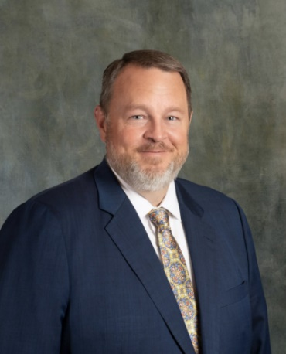

## Senator Lance Bell – Alabama Senate, District 11

**Lance Bell is the Senator for Alabama Senate, District 11 serving Shelby, St. Clair and Talladega Counties. Lance is a life-long St. Clair County resident. Lance practices law throughout the State of Alabama handling both plaintiff and civil matters as well as providing criminal defense services to his clients.**

**Lance worked for the St. Clair County Sheriff’s Department and District Attorney’s Office while obtaining his bachelor and law degree. Lance has been recognized by the Director of the FBI for his dedication and contributions to law enforcement involving a joint Federal and State kidnapping case.**

**Lance was Chairman of the St. Clair County Republican Party for six years and is currently the Chairman of the 3rd Congressional District Alabama Republican Party Executive Committee.**

**Lance has served/serves on several committees including Judiciary; State Governmental Affairs; Healthcare; Children and Youth Health; Tourism; Veterans, Military Affairs, and Public Safety; Shelby County Legislation and Permanent Legislative Committee on Reapportionment.**

**Lance has been active in politics for many years, even writing local legislation for St. Clair County.**

**Lance serves as the municipal judge for Ashville, Riverside, Childersburg, Ragland, and Ohatchee while prosecuting for the City of Pell City.**

**Lance and his wife Holly have two boys, Hudson and Holden.**

***Thank you to all our Presenters/Speakers for being part of the***

***2024 Alabama Conference and Convention.***

# Conference Exhibits

## Accessing Potential Through Assistive Technology (APTAT) (Formerly STAR program)

**Jessica McKay**

**Email:** [**jessica.mckay@rehab.alabama.gov**](mailto:jessica.mckay@rehab.alabama.gov)

**236 Goodwin Crest Drive**

**Homewood, Alabama 35209**

**Phone: (205) 290-4300**

## ADRS VRT & O&M Information

**Marge Lebrick**

**Email:** [**marge.lebrick@rehab.alabama.gov**](mailto:marge.lebrick@rehab.alabama.gov)

**236 Goodwin Crest Drive**

**Homewood, Alabama 35209**

**Phone: (205) 290-4308**

## AIDB AIRA-Gentry

**Doug Nixon**

**Email:** [**Nixon.doug@aidb.org**](mailto:Nixon.doug@aidb.org)

**1105 Fort Lashley Avenue**

**Talladega, Alabama 35160**

**Phone: (256) 761-3684**

## AIDB – Assistive Technology (AT)

**Kerry Dean**

**Email:** [**dean.kerry@aidb.org**](mailto:dean.kerry@aidb.org)

**220 34th Street South**

**Birmingham, Alabama 35222**

**Phone: (205) 328-3989**

## AIDB Birmingham Regional Center

**Stephanie Sims**

**Email:** [**sims.stephanie@aidb.org**](mailto:sims.stephanie@aidb.org)

**3420 3rd Avenue South**

**Birmingham, Alabama 35222**

**Business phone: (205) 328-3989, (256) 589-5468 (Stephanie Sims)**

## AIDB Center for Assistive Technology Training (CATT)

**Mary “Katy” Reid**

**Email:** [**reid.mary@aidb.org**](mailto:reid.mary@aidb.org)

**Physical address:**

**205 South Street East**

**Talladega, AL 35160**

**Mailing address:**

**P O BOX 698**

**Talladega, Alabama 35161**

**Business phone: (256) 589-1835   
(Director of CATT Stephanie Pizza)**

**Contact Phone: (256) 589-8421 (Katy Reid)**

## AIDB Huntsville Consumer Store

**Crystal Minter**

**Email:** [**minter.crystal@aidb.org**](mailto:minter.crystal@aidb.org)

**4092 Memorial Parkway SW Suite 105**

**Huntsville, Alabama 35803**

**Phone: (256) 539-7881**

**AIDB iCanConnect**

**Sybil Garrett**

**Email:** [**garrett.sybil@aidb.org**](mailto:garrett.sybil@aidb.org)

**1105 Fort Lashley Avenue**

**Talladega, Alabama 35160**

**Phone: (256) 761-3500**

## Alabama Association for the Education and Rehabilitation for the Blind and Visually Impaired, (AERBVI)

**Steve Sullivan**

**Email:** [**steve.sullivan119@gmail.com**](mailto:steve.sullivan119@gmail.com)

**6429 Pinehurst Run**

**Mobile, Alabama 36608**

**Phone: (251) 599-2808**

## Alabama Business Enterprise Program (BEP)

**Deborah Myrick**

**Email:** [**Deborah.myrick@rehab.alabama.gov**](mailto:Deborah.myrick@rehab.alabama.gov)

**602 South Lawrence Street**

**Montgomery, Alabama 36104**

**Phone: (334) 293-7253**

Alabama Council of the Blind – Huntsville Chapter

**Jenny Lux**

**Email:** [**myjslux81@gmail.com**](mailto:myjslux81@gmail.com)

**2075 Fisher Street SW Apt A4**

**Huntsville, Alabama 35803**

**Phone: (256) 425-7559 (Jenny Lux) or**

**(256) 603-8937 (Nancy Pendegraph)**

## Alabama Industries for the Blind

**Jeff Papalia**

**Email:** [**Papalia.jeff@aidb.org**](mailto:Papalia.jeff@aidb.org)

**1209 Fort Lashley Avenue**

**Talladega, Alabama 35160**

**Phone: (256) 761-3512**

## Alabama Library for the Blind and Physically Disabled

**Rhonda Napier**

**Email:** [**bph@apls.state.al.us**](mailto:bph@apls.state.al.us)

**6030 Monticello Drive**

**Montgomery, Alabama 36117**

**Phone: (334) 213-3906**

## A T Guys

**Damashe Thomas**

**Email:** [**support@atguys.com**](mailto:support@atguys.com)

**219 Old Orchard Place**

**Kalamazoo, Michigan 49306**

**Business phone: (269) 216-4798**

**Cell: (470) 535-2338 (Damashe Thomas)**

## Blind Girl Designs

**Tricia Waechter**

**Email:** [**tricia@blindgirldesigns.com**](mailto:tricia@blindgirldesigns.com)

**Website:** [**www.blindgirldesigns.com**](http://www.blindgirldesigns.com)

**Houston, Texas**

**Phone: (862) 448-1011**

## Blind Limitless Clothing LLC

**Haarem Averitte**

**Email:** [**Blindlimitless@gmail.com**](mailto:Blindlimitless@gmail.com)

**P.O. BOX 1281**

**Talladega, Alabama 35160**

**Phone: (470) 726-7648**

## Emerald Coast Vision Aids

**Adam Suitor**

**Email:**[**adam@emeraldcoastvisionaids.com**](mailto:adam@emeraldcoastvisionaids.com)

**163 East Burgess Road**

**Pensacola, Florida 32503**

**Phone: (850) 473-8081**

**JW.ORG**

**Patrick Pegues**

**Email:** [**pjpegues@gmail.com**](mailto:pjpegues@gmail.com)

**861 Cody Circle**

**Fultondale, Alabama 35068**

**Phone: (205) 901-0548**

## Lakeshore Foundation

**Chris Thomason**

**Email:** [**christophert@lakeshore.org**](mailto:christophert@lakeshore.org)

**4000 Ridgeway Drive**

**Birmingham, Alabama 35209**

**Phone: (205) 313-7400**

## OrCam Inc.

**Andrew Planchard**

**Email** [**andrew.planchard@orcam.com**](mailto:andrew.planchard@orcam.com)

**1115 Broadway, 11th Floor**

**New York, New York 10010**

**Phone: (225) 210-3776**

## Tactile Engineering

**Wunji Lau**

**Email:** [**wlau@tactile-engineering.com**](mailto:wlau@tactile-engineering.com)

**3601 Sagamore Parkway North, Suite C**

**Lafayette, Indiana 47904**

**Business phone: (317) 201-5335**

**Cell phone: (765) 532-4534 (Dave Schleppenbach, cell)**

## UAB Department of Occupational Therapy

**Dr. Jason Vice and Mrs. Sarah Beth Spraberry**

**Email:** [**vzajic@uab.edu**](mailto:vzajic@uab.edu)

**UAB School of Health Professions  
1720 University Blvd., SHP 342**

**Birmingham, Alabama 35242**

**Phone: (205) 996-9497**

## United Way Area Agency On Aging (UWAAA)

**Ashley Lemsky**

**Email:** [**aaa@uwaaa.org**](mailto:aaa@uwaaa.org)

**3600 8th Avenue South**

**Birmingham, Alabama 35232**

**Phone: (800) 243-5463**

## Veterans Affairs Blind Rehabilitation Services Birmingham VA Health Care System

**Venita Beaty**

**Visual Impairment Services Team (VIST) Coordinator)**

**Email:** [**Venita.beaty@va.gov**](mailto:Venita.beaty@va.gov)

**700 19th Street South**

**Birmingham, Alabama 35233**

**Phone: (205) 933-4389**

**Thank you to all our exhibitors for being part of the**

**2024 Alabama Conference and Convention.**

**Have a safe trip home!**